How WWP works:
Each lesson in the book is comprised of 5 days of Scripture reflection that takes no more than 15 minutes of your day and is created to easily fit into your free moments. Prayer time and a weekly resolution to cement what you have grasped is also part of your daily lesson.
Participants gather together in their small group, facilitated by table leaders, to discuss the lesson, reflect, and pray together in fellowship.
When: 22 select Thursdays, morning (9:15-10:45) or evening (7:30-9:00), beginning September 27 through April, with breaks for holidays and certain parish events.
Cost: Study guide: $40 plus shipping at: https://walkingwithpurpose.com/shop/books/. We will also collect a freewill donation to help us offset hospitality expenses. If you are unable to pay for a book, please reach out to Jen Rice at jrice@stbrendans.net . No woman will be turned away!
2018-19 Courses:
We will offer two different WWP courses, Opening Your Heart and Discovering Our Dignity. If you are new to WWP, please enroll in Opening Your Heart as this is the foundational course and introduces you to Scripture study in this format. We have found that jumping into a high level course without completing OYH can be frustrating for the participant as she tries to grow a garden without preparing the soil.
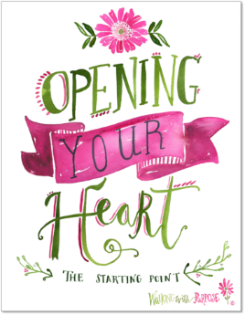
Opening Your Heart: The Starting Point
Opening Your Heart: The Starting Point is our 22-week foundational course, designed for women who are new to Walking with Purpose. Join us as we take a deeper dive into some core questions as we strive to experience all that God has for us.

Some of the questions explored are: How can I conquer my fears? What is the role of the Holy Spirit in my life? What does the Eucharist have to do with my friendship with Christ? What is the role of suffering in my life? What challenges will I face in my efforts to follow Jesus more closely?
Discovering Our Dignity: The Women of the Bible
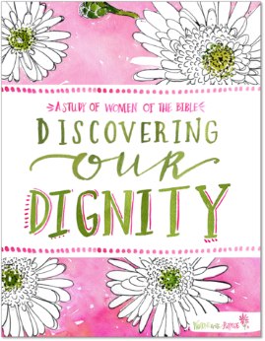
Discovering our Dignity, a 22-week Bible study, gives us modern-day advice from women of the Bible. Ancient wisdom, sage advice, sorrowful failures and woundedness…as heard from figures like Sarah, Ruth, Esther, and Martha and Mary of Bethany.
In Discovering our Dignity, we learn that women of the Old and New Testament were sometimes as flawed and broken as we can be. Yet, the power of God worked in their lives. Through their stories recorded in Scripture, they reach out to touch our “present” in a tender, honest and loving way –woman to woman.

